## Task 1 : Launching an EC2 Instance

1. Make sure you are in the US East **(N. Virginia) us-east-1**Region.
2. Navigate to EC2 by clicking on the  menu in the top, then click on **EC2** in the **Compute**section.
3. Navigate to **Instances** on the left panel and click on Button**.**
4. Name : Enter **MyEC2Server**

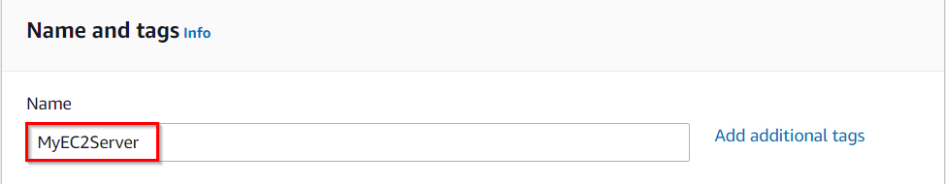

1. **For Amazon Machine Image (AMI):** Search for **Amazon Linux 2 AMI** in the search box and click on the **Select**button.  
   **Note: if there are two AMI's present for Amazon Linux 2 AMI, choose any of them.**
2. **For Instance Type:** select **t2.micro**

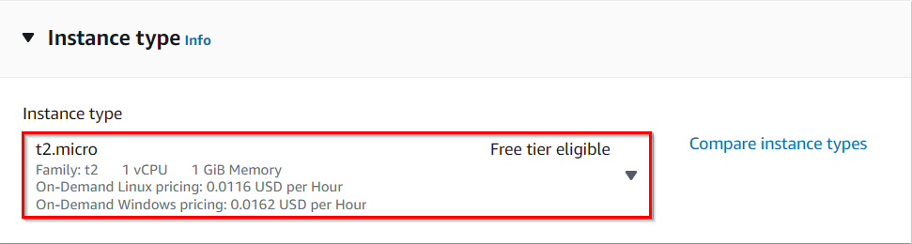

1. **For Key pair:**Select **Create a new key pair**Button
   * Key pair name: **LabKey**
   * Key pair type: **RSA**
   * Private key file format: **.pem or .ppk**
2. Select **Create key pair** Button.

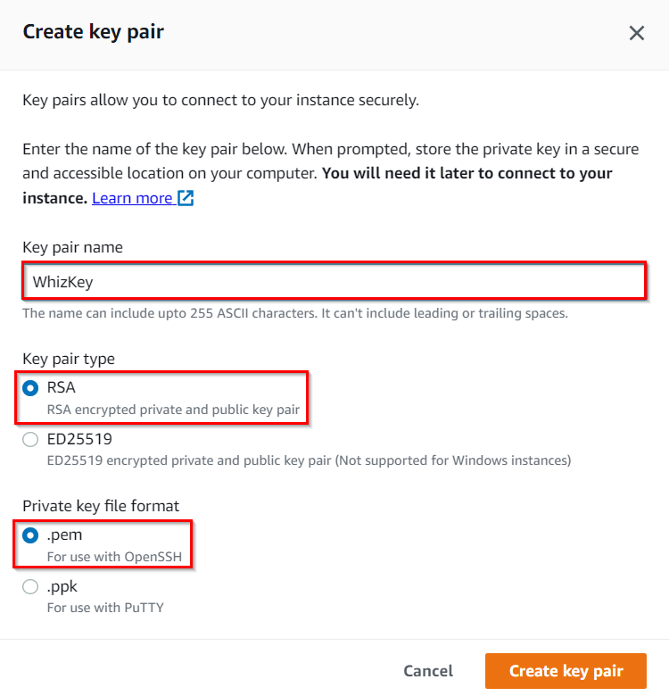

1. In Network Settings Click on **Edit** Button:

* Auto-assign public IP: **Enable**
* Select **Create new Security group**
* Security group name : Enter **MyEC2Server_SG**
* Description : Enter **Security Group to allow traffic to EC2**

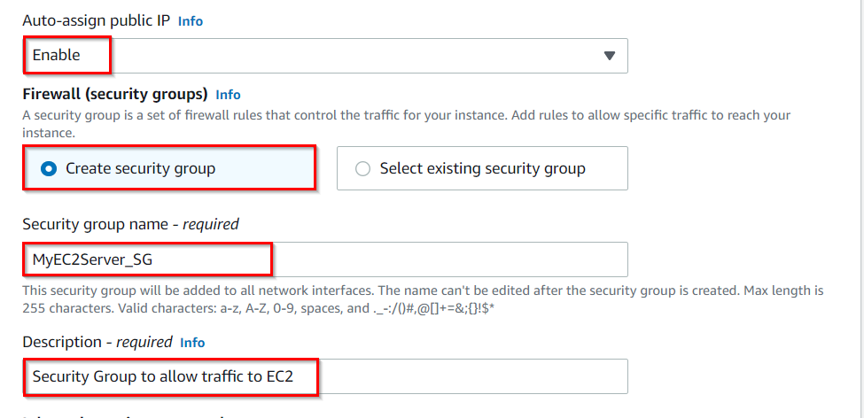

* Check Allow SSH from and Select Anywhere from dropdown
* To add **SSH**,
  1. Choose Type: 
  2. Source: Select 
* For **HTTP,**Select **Add Security rule**Button
  1. Choose Type: **HTTP**
  2. Source:  Select 

1. Keep Rest thing Default and Click on **Launch Instance**Button.
2. Select **View all Instances** to View Instance you Created
3. **Launch Status:** Your instances are now launching, Navigate to **Instances** page from left menu and wait the status of the EC2 Instance changes to running and health check status changes to 

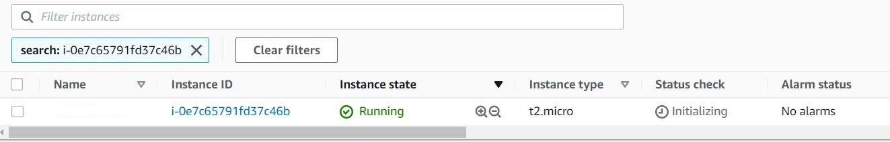

1. Note down the sample IPv4 Public IP Address of the EC2 instance. A sample is shown in the screenshot below.

## 

## Task 2 : SSH into EC2 Instance

1. Select your EC2 instance(**MyEC2Server**) and click on the **Connect**button.

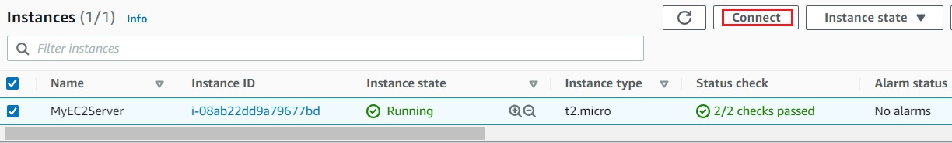

1. Select **EC2 Instance Connect**option and click on **Connect**button.(Keep everything else as default)

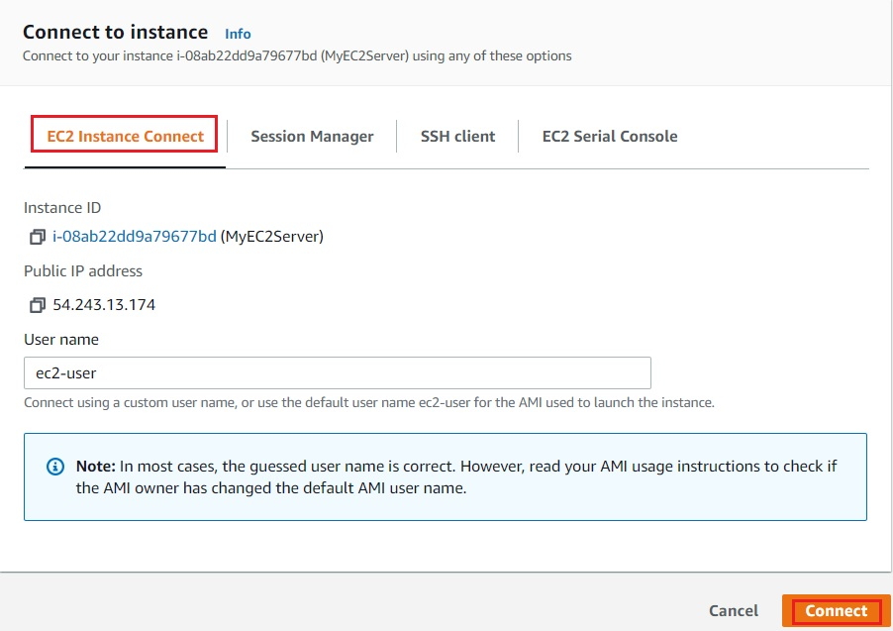

1. A new tab will open in the browser where you can execute the CLI Commands.

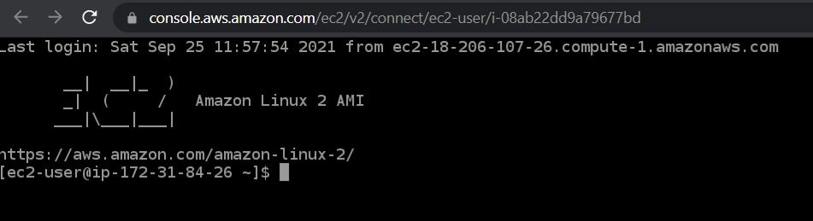

## Task 3: Install an Apache Server

1. Switch to root user:

|  |
| --- |
| sudo su |

1. Now run the updates using the following command:
   * yum -y update
2. Once completed, lets install and run an apache server
   * Install the Apache web server:
     + yum install httpd -y
   * Start the web server
     + systemctl start httpd
   * Now enable httpd:
     + systemctl enable httpd
   * Check the webserver status
     + systemctl status httpd
   * You can see Active status is running.
   * You can test that your web server is properly installed and started by entering the **public IPv4 address** of your **EC2 instance** in the address bar of a web browser. If your web server is running, then you see the Apache test page. If you don't see the Apache test page, then verify whether you followed the above steps properly and check your inbound rules for the security group that you created.

## Task 4 : Create and publish the page

1. To add the contents into index.html file using echo, copy and paste the below command to shell.
   * echo "<html>Hi All, I am a public page</html>" > /var/www/html/index.html
2. Restart the webserver by using the following command:
   * systemctl restart httpd
3. Now enter the file name, **/index.html** after the **public IPv4 Address** which you got when you created the ec2 instance in the browser, and you can see your HTML content.
   * Make sure **URL Protocol** is **http**not https.
   * Syntax: **http://<Your_Public_IPv4_Address>/index.html**
   * Sample URL: **http://52.87.50.168/index.html**
   * **Note:** If the index.html page is not loading, try removing **s** from the link, it should be HTTP.

       6. If you can see the above text in the browser, then you have successfully completed the lab.